Module 12 – Tableau Prep
Difference Between Tableau Desktop and Tableau Prep
Tool | Purpose
Tableau Desktop | Data analysis, visualization, dashboards, and reports
Tableau Public | Free version for creating and sharing public dashboards
Tableau Prep | Cleaning, transforming, combining, and shaping data before analysis

12.1 Introduction to Tableau Prep
What is Tableau Prep?
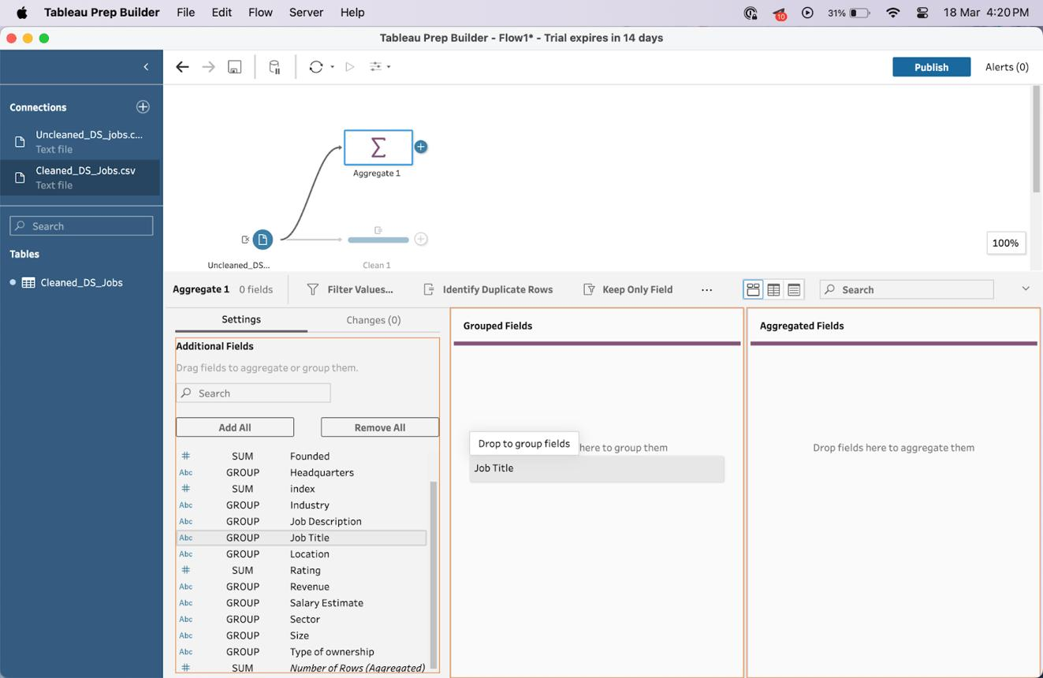
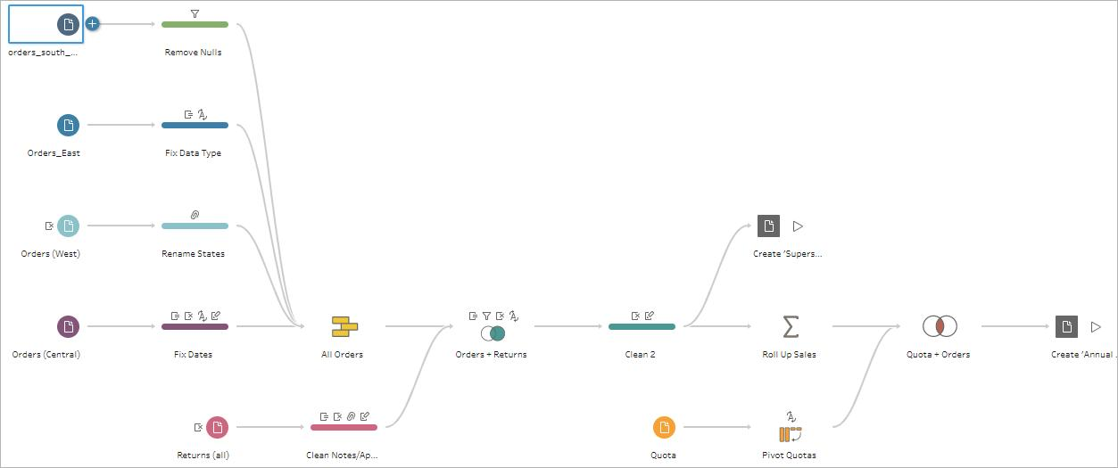
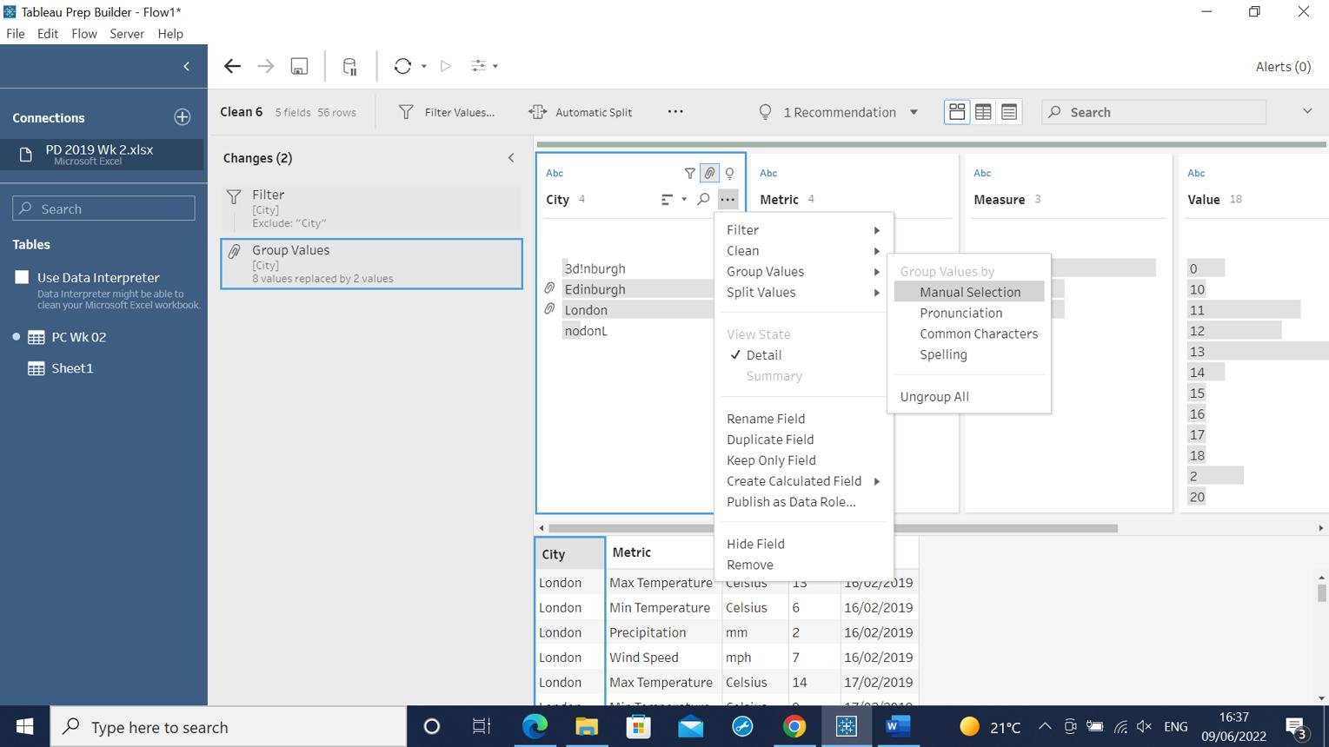

Tableau Prep is a data preparation tool used to clean, combine, shape, and organize data before analyzing it in Tableau.
It helps users:
- Clean messy data
- Remove Null value(upload data, than go to sheet1, drag-sales in column, Customer Name in row, Postal code in filter, select all and uncheck null and ok)
- Merge data from multiple sources
- Remove duplicates
- Handle missing values
- Prepare data quickly for dashboards and reports
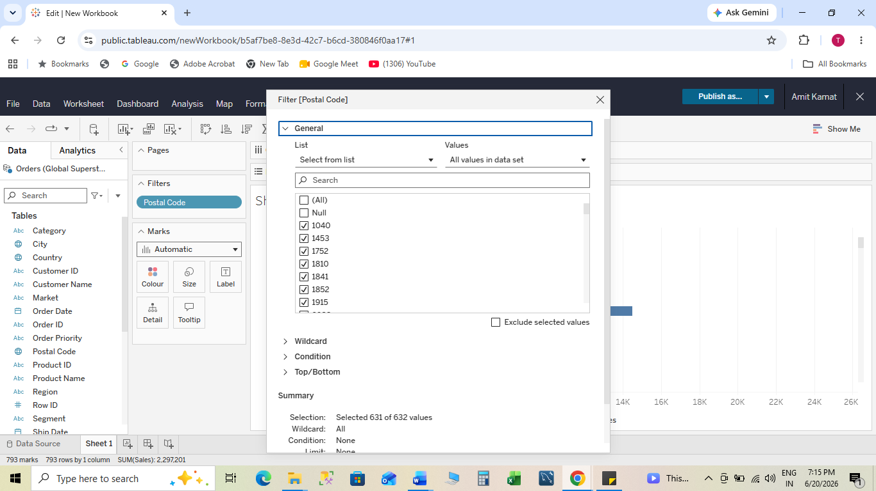
Benefits
✔ Easy drag-and-drop interface
✔ No coding required
✔ Visual data preparation
✔ Faster data cleaning
✔ Better data quality
1.)Keep Only-keep only column you need
2.)Duplicate field-create Duplicate column
3.)Remove Letters
4.)Remove Punctuation
5.)Change data type
6.)Remove Numbers
7.)Trim space(left and right both side)
8.)Make Uppercase
9.)Make Lowercase
10.)Split Value-than custom split
12.2 How Tableau Prep Helps Quickly Combine, Join, Shape, and Clean Data
Data Preparation Process
Connect Data
↓
Clean Data
↓
Join / Union Data
↓
Shape Data
↓
Output Clean Data
↓
Analyze in Tableau
Step 1: Connect Data
- Open Tableau Prep Builder
- Click Connect
- Select data source:
  - Excel
  - CSV
  - SQL Server
  - Oracle
  - MySQL
Step 2: Clean Data
Common cleaning tasks:
- Rename fields
- Remove null values
- Change data types
- Remove duplicates
- Split columns
Example
Before Cleaning
Customer | City
Amit | Delhi
Null | Mumbai
Rahul | Delhi
After Cleaning
Customer | City
Amit | Delhi
Rahul | Delhi
Step 3: Join Data
Suppose we have:
Orders Table
Order ID | Customer ID
101 | C01
102 | C02
Customers Table
Customer ID | Customer Name
C01 | Amit
C02 | Rahul
Join on Customer ID
Result:
Order ID | Customer Name
101 | Amit
102 | Rahul
Step 4: Output Data
- Click +
- Select Output
- Save as:
  - Hyper File
  - CSV File

12.3 Creation of Smart Examples with Tableau Prep
Example: Sales Analysis
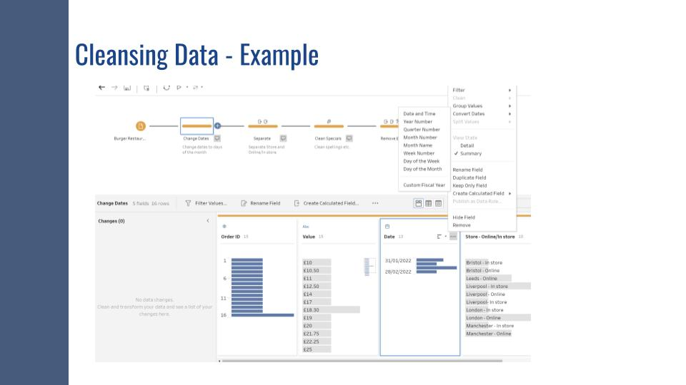
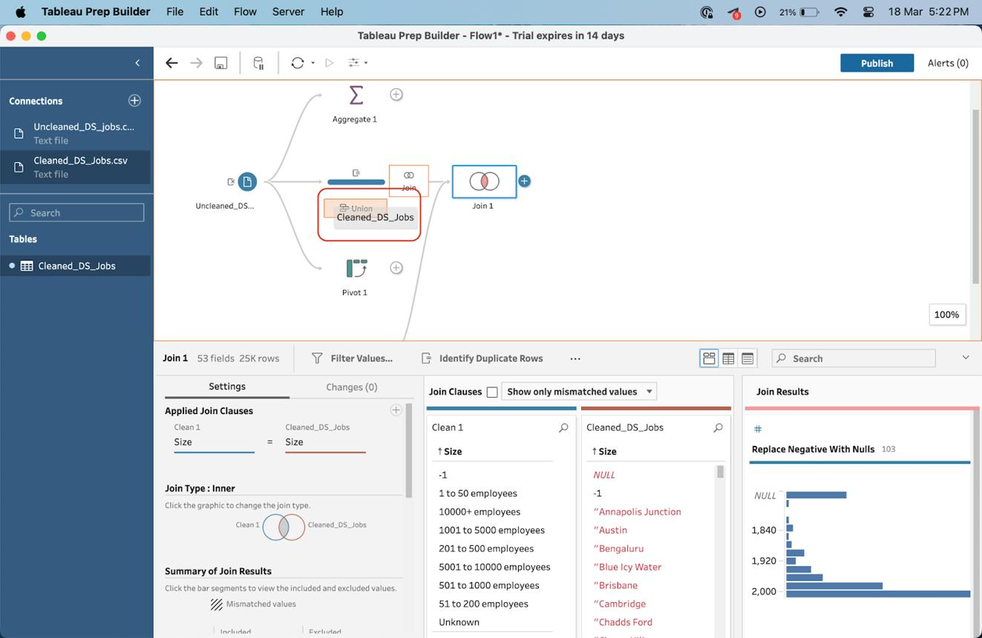
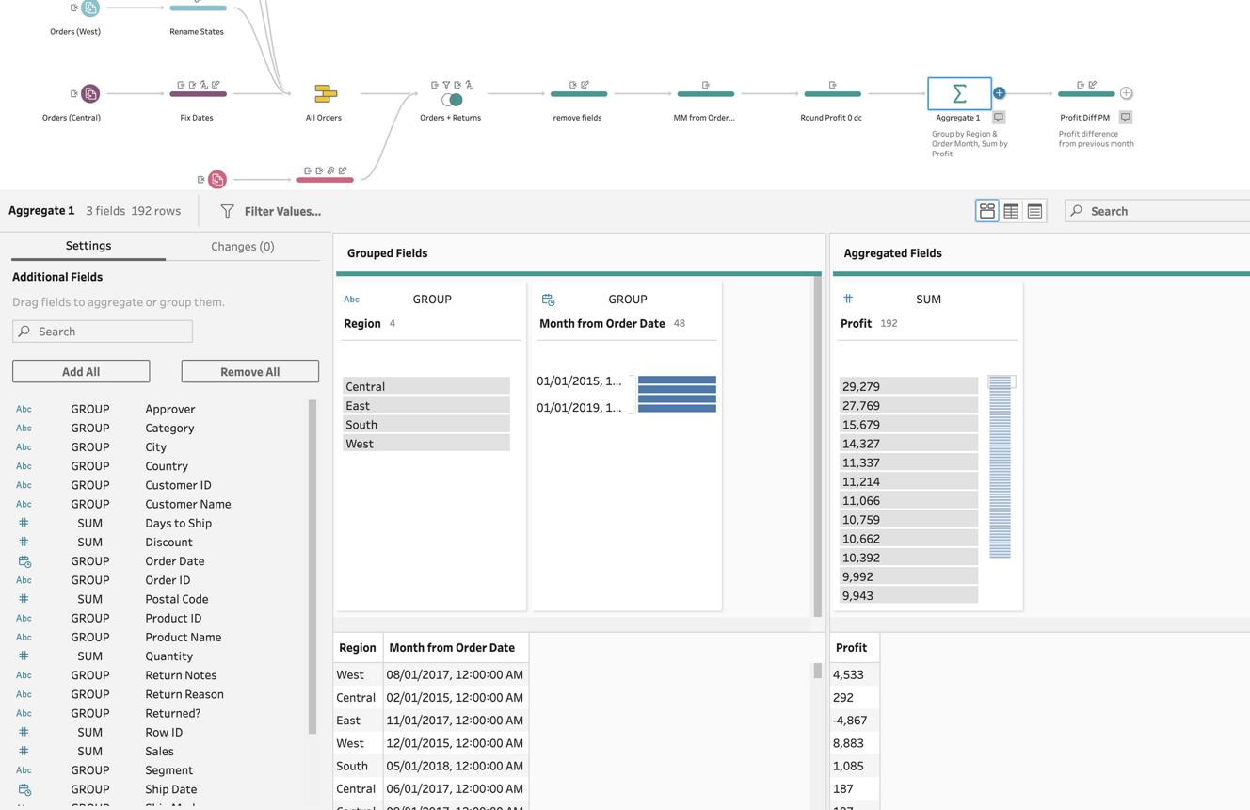

Scenario
Company has:
- Sales.xlsx
- Customers.xlsx
- Products.xlsx
Steps
Step 1
Connect all three files.
Step 2
Clean data:
- Remove nulls
- Standardize names
- Correct date formats
Step 3
Join tables:
- Sales → Customers
- Sales → Products
Step 4
Create calculated field:
Profit = Sales - Cost
Step 5
Aggregate by Product
Output:
Product | Sales | Profit
Laptop | 500000 | 150000
Mobile | 300000 | 90000
Step 6
Export cleaned dataset.

12.4 Getting Deeper Insights into Data with Great Visual Experience
Tableau Prep Visual Features
Profile Pane
Shows:
- Distinct values
- Null values
- Data distribution
Data Grid
Shows:
- Actual records
- Errors
- Missing values
Flow Pane
Displays complete workflow visually.
Example Insight
Customer Age Data:
Age
25
30
Null
45
Prep immediately highlights:
- Null values
- Outliers
- Invalid entries
This helps improve analysis accuracy.
Benefits
✔ Better understanding of data
✔ Faster issue detection
✔ Visual validation
✔ Improved decision making

12.5 Making Data Preparation Simpler and Accessible
Key Features
1. Drag-and-Drop Interface
No SQL knowledge required.
2. Automatic Recommendations
Prep suggests:
- Group values
- Fix spelling errors
- Merge categories
3. One-Click Cleaning
Examples:
Before:
State
Bihar
BIHAR
bihar
After Group & Replace:
State
Bihar
Bihar
Bihar
4. Reusable Flows
Save workflow and run again when new data arrives.
Steps to Create Reusable Flow
- Build cleaning workflow
- Save Flow (.tfl)
- Refresh source data
- Run flow again
- Updated output generated automatically

12.6 Integrating Tableau Prep with Tableau Analytical Workflow
Complete Tableau Workflow
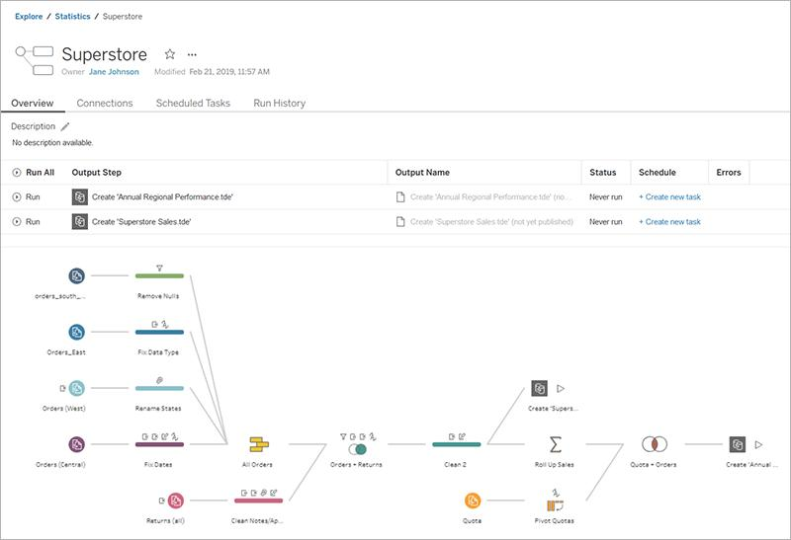
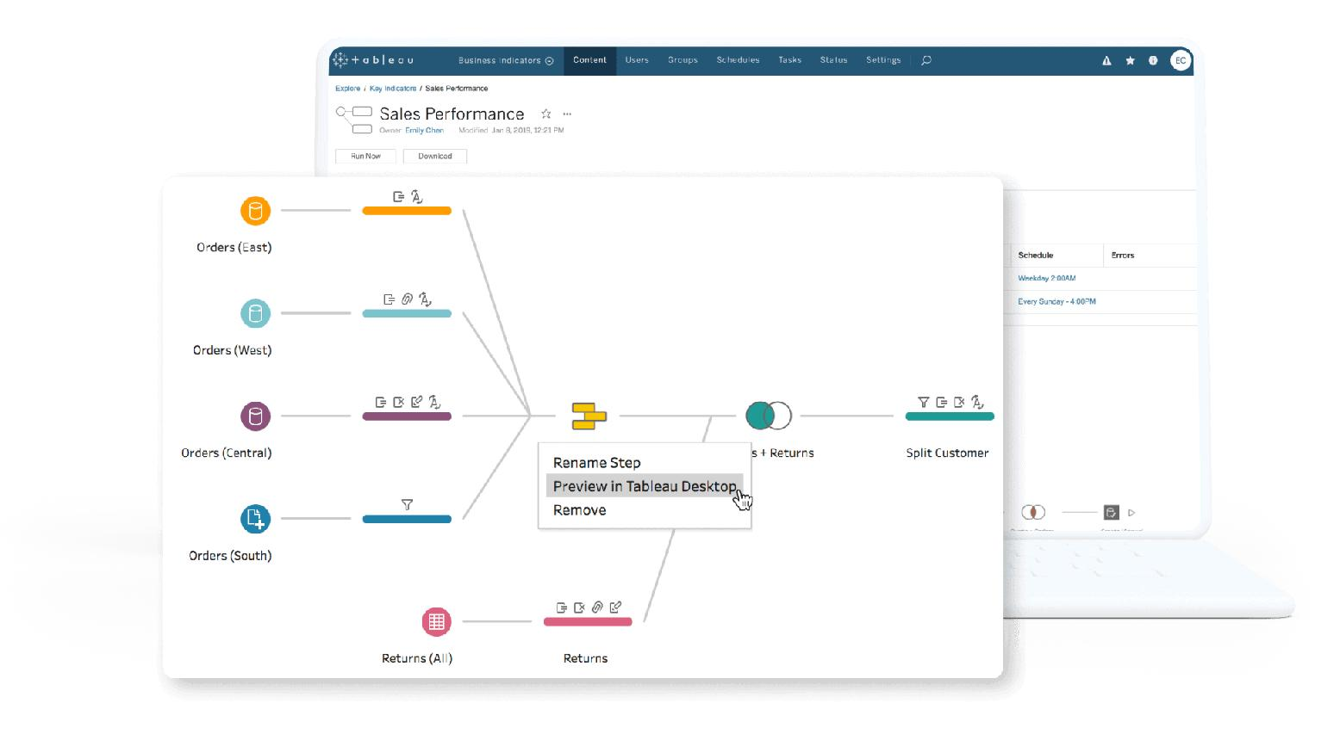
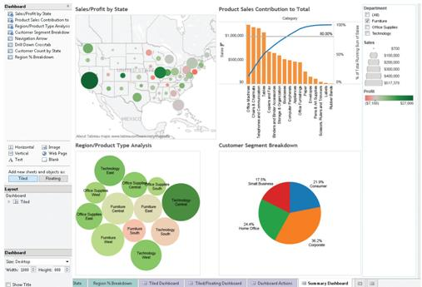

Raw Data
↓
Tableau Prep
↓
Clean Dataset
↓
Tableau Desktop
↓
Visualizations
↓
Dashboard
↓
Business Insights
Step-by-Step Integration
Step 1: Prepare Data in Tableau Prep
- Clean data
- Join tables
- Remove errors
Step 2: Create Output
Choose:
Output → Hyper File
Step 3: Open Tableau Desktop
- Launch Tableau Desktop
- Click Connect
- Select Hyper File
Step 4: Build Visualizations
Examples:
- Sales Trend
- Profit Analysis
- Customer Segmentation
- Regional Performance
Step 5: Create Dashboard
Add:
- KPI Cards
- Bar Charts
- Maps
- Filters
Step 6: Publish
Publish to:
- Tableau Server
- Tableau Cloud

Interview Questions
Q1. What is Tableau Prep?
A data preparation tool used to clean, combine, and shape data before analysis.
Q2. What are the main steps in Tableau Prep?
Connect → Clean → Join → Aggregate → Output.
Q3. What is a Flow?
A visual representation of data preparation steps.
Q4. What output formats are supported?
- Hyper
- CSV
Q5. Why use Tableau Prep?
To improve data quality and reduce time spent on manual data cleaning.
Exam Note
Tableau Prep = Connect Data + Clean Data + Join Data + Shape Data + Output Data → Tableau Dashboard

